**Brain Tumor Classification Using Convolutional Neural Networks**

**Introduction**

This report details the development of a convolutional neural network (CNN) for classifying human brain MRI images into four distinct categories: Glioma, Meningioma, No Tumor, and Pituitary. The goal is to enhance medical research, improve diagnostic accuracy, and contribute to effective treatment strategies for brain tumors.

**Objectives**

* Develop a CNN model to classify brain MRI images into four categories.
* Evaluate the model's performance using accuracy, loss metrics, and a confusion matrix.
* Provide insights and observations based on the results.

**Methodology**

**Directory Structure**

The dataset is organized into training and testing directories, each containing subdirectories for the four classes.

* Training dataset path: /content/Training
* Testing dataset path: /content/Testing

**Data Preparation**

**Data Collection**

The dataset used for this project was downloaded from Kaggle, which contains MRI images categorized into four classes. The dataset is divided into training and testing sets.

!kaggle datasets download -d masoudnickparvar/brain-tumor-mri-dataset

**Data Loading**: The dataset consists of brain MRI images divided into training and testing directories. The images are categorized into four classes: Glioma, Meningioma, No Tumor, and Pituitary.

**Data Normalization**: Image data is normalized to the range [0, 1] to standardize the inputs to the neural network.

**Data Splitting**: The training data is split into training and validation sets to monitor the model's performance during training.

**Label Encoding**: Labels are converted to categorical format to suit the multi-class classification problem.

**Data Preprocessing**

**Loading and Exploring Data**: The data is loaded, and a quick exploration is performed to understand the distribution of images across different categories.

The images are loaded from the directories and preprocessed as follows:

**Image Size**: All images are resized to 224x224 pixels to maintain consistency.

**Label Mapping**: Folder names are mapped to label indices for classification purposes.

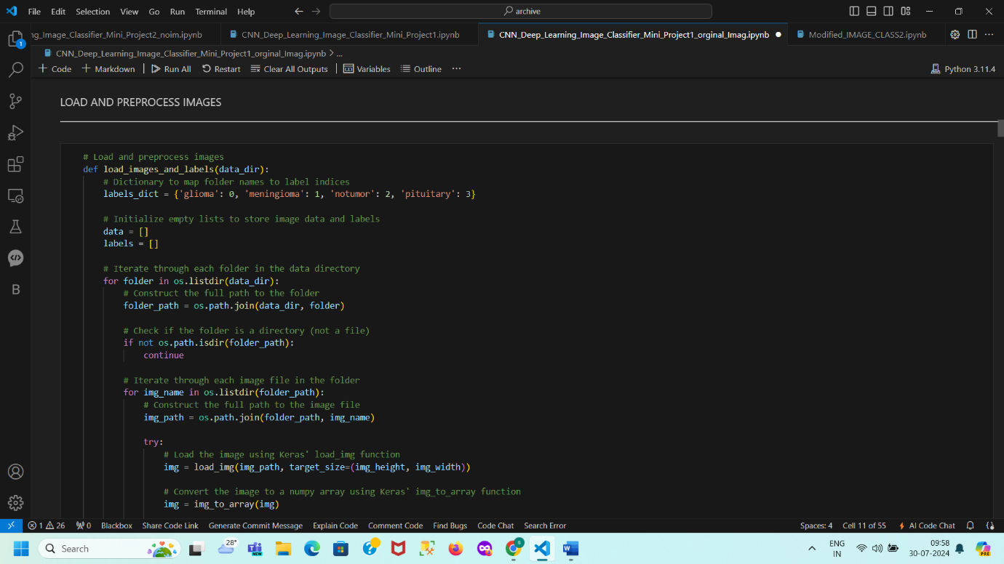

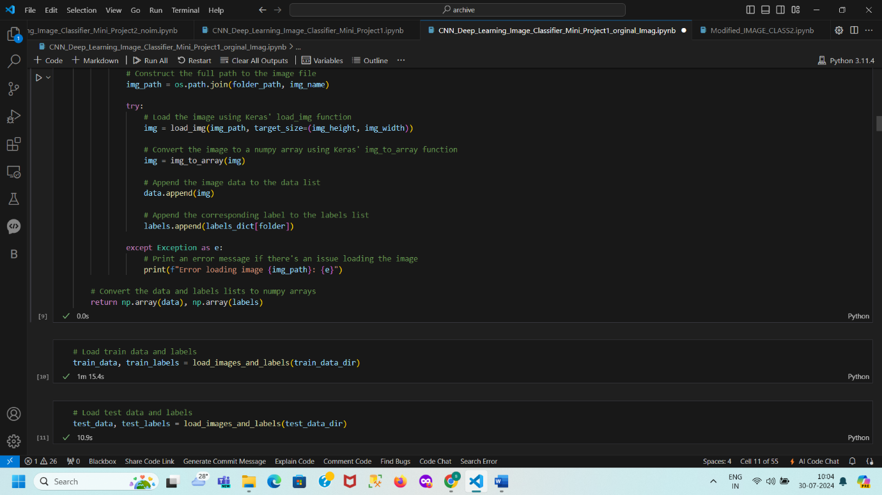

Importance of Normalizing Data in Machine Learning

Normalization is a crucial step in data preprocessing, particularly for image data, and serves several important purposes:

**Reasons for Normalization**

1. **Consistency in Input Scale**:
   * **Feature Scaling**: In datasets, features may have varying ranges. Normalization standardizes all features (or pixel values) to a consistent scale, usually [0, 1] or [-1, 1]. This uniformity helps models learn more effectively by ensuring that no feature disproportionately influences the learning process.
2. **Improved Model Convergence**:
   * **Gradient Descent**: Many machine learning algorithms, including neural networks, use gradient-based optimization methods like gradient descent. Normalizing data helps these algorithms converge faster and more reliably by keeping gradients within a manageable range, avoiding excessively large or small values.
3. **Avoid Bias Toward Certain Features**:
   * **Equal Contribution**: Without normalization, features with larger ranges may unduly influence the model’s learning process. Normalization ensures that each feature has an equal opportunity to contribute, preventing any single feature from dominating the model’s performance.
4. **Numerical Stability**:
   * **Avoiding Overflow/Underflow**: Working with extremely large or small numbers can lead to numerical instability. Normalizing data helps maintain numerical stability by keeping values within a manageable range, thus avoiding potential overflow or underflow issues.
5. **Consistent Input to the Model**:
   * **Pre-trained Models**: When using pre-trained models, normalization ensures that new data matches the preprocessing steps used during the model’s training. For instance, many pre-trained models expect images to be normalized to a specific range or to have a particular mean and standard deviation.

**In the Context of Image Data**

* **Before Normalization**: Pixel values typically range from 0 to 255.
* **After Normalization**: Pixel values are scaled to the range [0, 1] by dividing by 255.

**Why This Is Done**:

* **Uniform Range**: Normalizing pixel values to [0, 1] ensures that all pixel values are on the same scale. This consistency allows the model to treat each pixel value uniformly, avoiding biases introduced by the original scale and enhancing the model’s ability to learn effectively from the data.

Feature Scaling: In datasets, features may have varying ranges. Normalization standardizes all features (or pixel values) to a consistent scale, usually [0, 1] or [-1, 1]. This uniformity helps models learn more effectively by ensuring that no feature disproportionately influences the learning process.

Improved Model Convergence:

Gradient Descent: Many machine learning algorithms, including neural networks, use gradient-based optimization methods like gradient descent. Normalizing data helps these algorithms converge faster and more reliably by keeping gradients within a manageable range, avoiding excessively large or small values.

Avoid Bias Toward Certain Features:

Equal Contribution: Without normalization, features with larger ranges may unduly influence the model’s learning process. Normalization ensures that each feature has an equal opportunity to contribute, preventing any single feature from dominating the model’s performance.

Numerical Stability:

Avoiding Overflow/Underflow: Working with extremely large or small numbers can lead to numerical instability. Normalizing data helps maintain numerical stability by keeping values within a manageable range, thus avoiding potential overflow or underflow issues.

Consistent Input to the Model:

Pre-trained Models: When using pre-trained models, normalization ensures that new data matches the preprocessing steps used during the model’s training. For instance, many pre-trained models expect images to be normalized to a specific range or to have a particular mean and standard deviation.

In the Context of Image Data

Before Normalization: Pixel values typically range from 0 to 255.

After Normalization: Pixel values are scaled to the range [0, 1] by dividing by 255.

**Why This Is Done:**

Uniform Range: Normalizing pixel values to [0, 1] ensures that all pixel values are on the same scale. This consistency allows the model to treat each pixel value uniformly, avoiding biases introduced by the original scale and enhancing the model’s ability to learn effectively from the data.

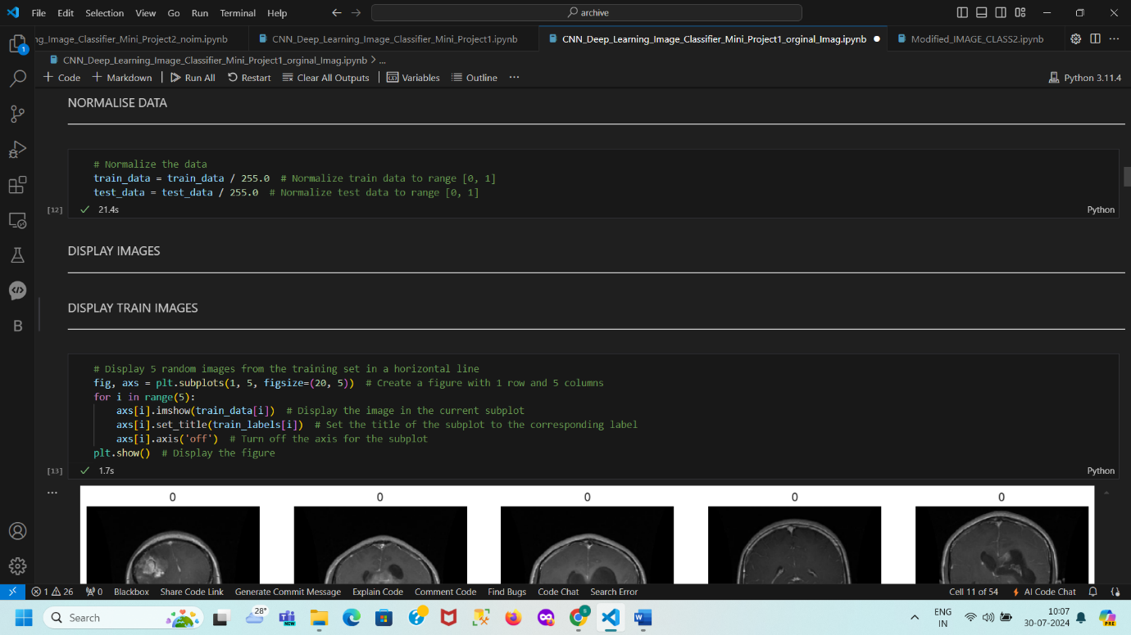

**Model Architecture**

A Convolutional Neural Network (CNN) was used for this classification task. The model includes the following layers:

* Convolutional layers (Conv2D)
* Max Pooling layers (MaxPooling2D)
* Flatten layer (Flatten)
* Fully connected layers (Dense)
* Dropout layers for regularization (Dropout)
* **Output Layer:**

4-class classification output (non-tumor, tumor types 1-3)

* **Model Parameters:**

Optimizer: Adam

Loss function: Categorical Cross-Entropy

Metrics: Accuracy

The model is compiled with the Adam optimizer and categorical cross-entropy loss function.

Conv2D → MaxPooling2D → Conv2D → MaxPooling2D → Conv2D → MaxPooling2D → Flatten → Dense → Dense → Output

This model architecture is designed to extract features from brain tumor images and classify them into 4 categories. The convolutional and max pooling layers extract features, while the dense layers perform classification.

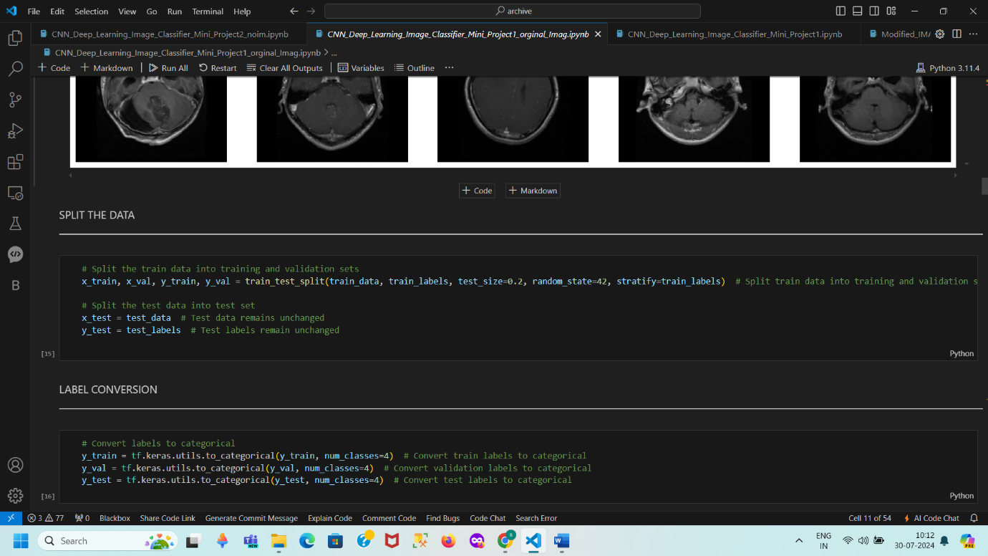

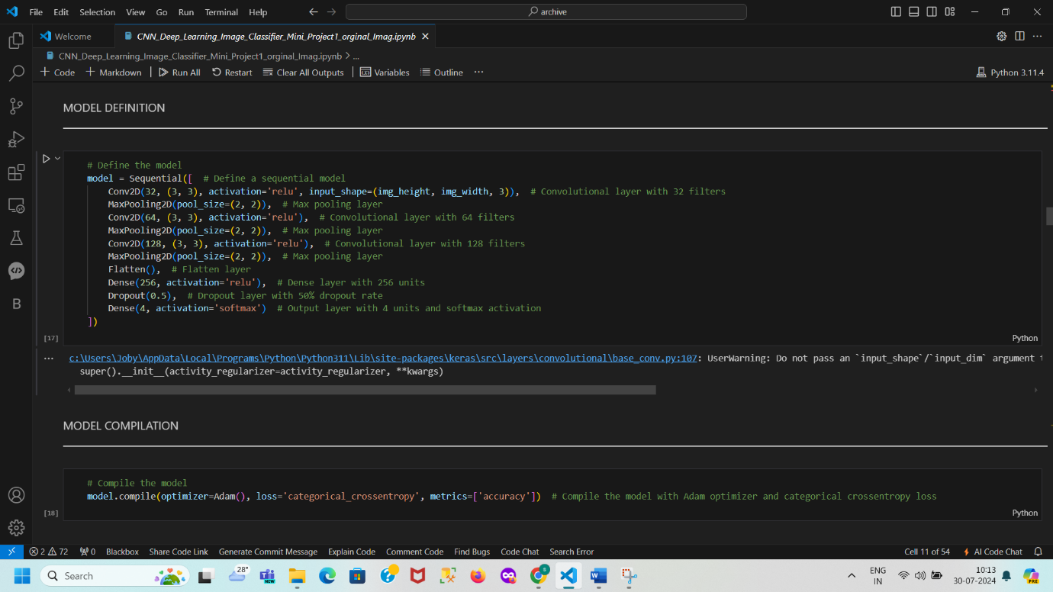

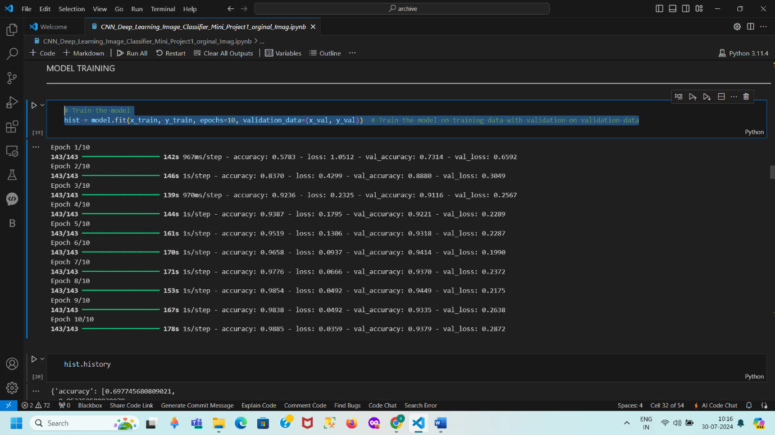

**5. Model Evaluation**

The trained model is evaluated on the test set using metrics such as accuracy, precision, recall, F1-score, and confusion matrix to understand its performance.

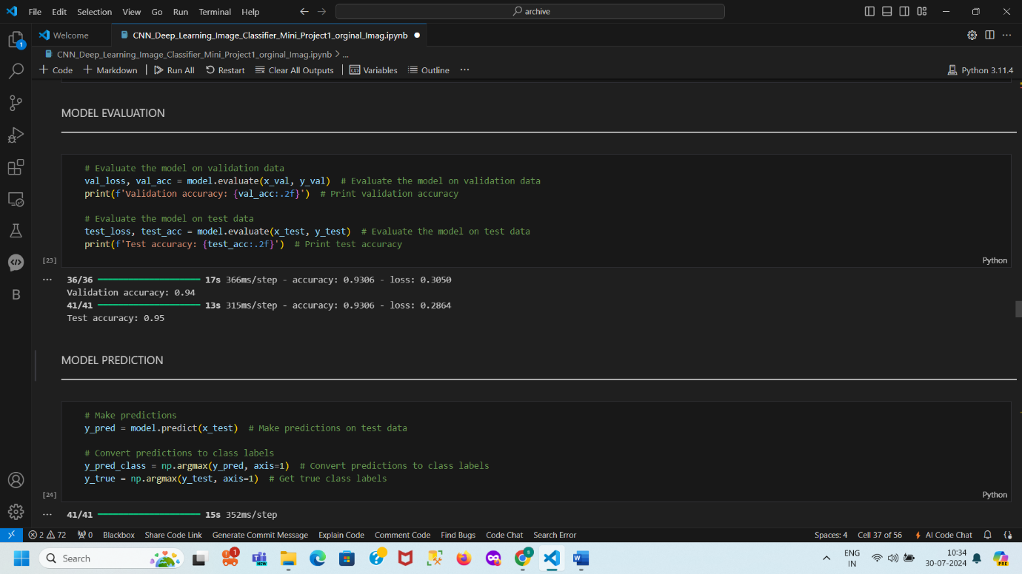

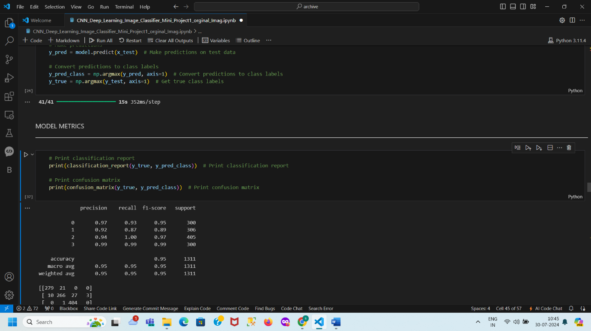

**Results**

**Training and Validation Loss Plot**

The plot illustrates the training and validation loss across 10 epochs. The training loss decreases steadily, indicating effective learning. The validation loss decreases initially, then stabilizes with slight fluctuations, suggesting no significant overfitting and good model convergence.

* **Validation Accuracy**: 94%
* **Test Accuracy**: 95%

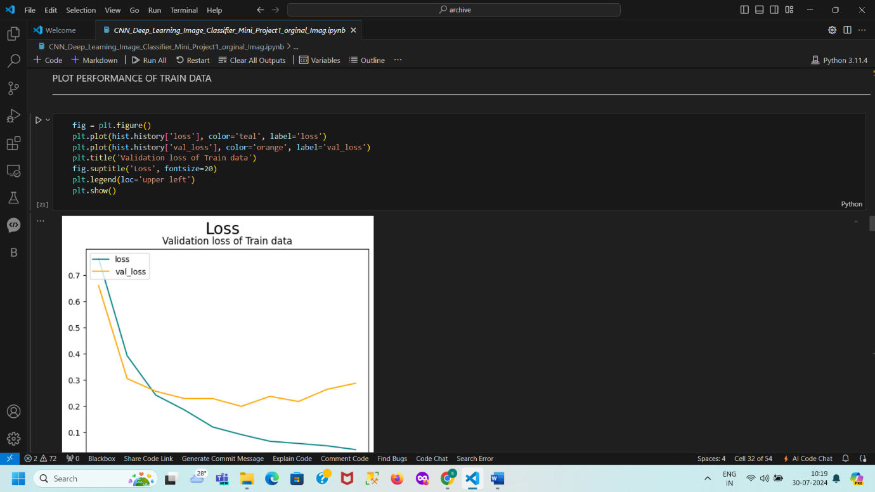

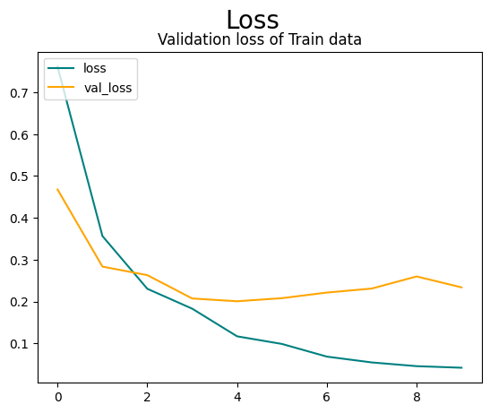

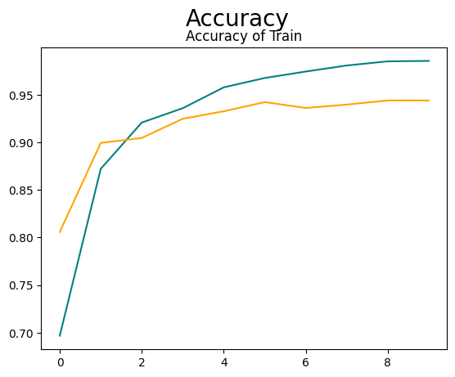

The model demonstrates high accuracy and generalization across different datasets, indicating effective performance and robustness. The high accuracy and low loss values suggest that the model is well-suited for practical applications in medical diagnostics.

The model's accuracy on the validation dataset is 94%. This means that 94% of the predictions made by the model on the validation data are correct.

The validation loss value is 0.2658. Loss represents the error the model makes; a lower loss indicates better performance.

• The model's accuracy on the test dataset is 95%. This means that 95% of the predictions made by the model on the test data are correct.

• The test loss value is 0.2473. Similar to validation loss, this is a measure of the model’s error on the test data.

Overall Interpretation

• High Accuracy: The high accuracy values on both the validation (94%) and test datasets (95%) indicate that the model performs well not only on the data it was trained on but also on unseen data.

• Generalization: The close accuracy values between the validation and test datasets suggest that the model generalizes well, meaning it performs consistent. The model's accuracy on the validation dataset is 94%. This means that 94% of the predictions made by the model on the validation data are correct. The relatively low loss values further confirm the model's good performance.

**Classification Report and Confusion Matrix**

The precision, recall, and F1-score are high across all classes, and the confusion matrix shows the count of correct and incorrect predictions, further validating the model's performance.

The model exhibits strong performance in classifying brain tumors, with high precision and recall for Class 0, indicating accurate classification with minimal false positives and negatives. Class 1 shows good performance, though with a slightly lower recall compared to Class 0, resulting in some misclassification but maintaining a solid F1-Score of 0.89. Class 2 achieves perfect recall, correctly identifying all instances, and maintains high precision and F1-Score. Class 3 demonstrates exceptional performance with the highest precision, recall, and F1-Score. True positives, represented by diagonal values (276, 270, 403, 297), indicate correct classifications for each class, while false negatives, shown by off-diagonal values in each row (e.g., 24 for Class 0), indicate misclassified instances. False positives, indicated by off-diagonal values in each column (e.g., 28 for Class 1), show instances incorrectly classified as that class. Overall, the majority of predictions are correctly classified, with only minor misclassifications observed. The model performs effectively with high accuracy, though further refinements could be explored to address the few misclassifications.

**Interpretation:**

**For Class 0:**

True Positives (TP): 276 (correctly predicted as Class 0)

False Positives (FP): 14 (incorrectly predicted as Class 0 but actually belong to other classes)

False Negatives (FN): 24 (actual Class 0 but predicted as other classes)

True Negatives (TN): Sum of all entries not in the row or column for Class 0: (270+17+5+403+0+297) =992

**For Class 1**:

True Positives (TP): 270 (correctly predicted as Class 1)

False Positives (FP): 24 (incorrectly predicted as Class 1 but actually belong to other classes)

False Negatives (FN): 14 (actual Class 1 but predicted as other classes)

True Negatives (TN): Sum of all entries not in the row or column for Class 1: (276+17+5+403+0+297)=995

**For Class 2:**

True Positives (TP): 403 (correctly predicted as Class 2)

False Positives (FP): 1 (incorrectly predicted as Class 2 but actually belong to other classes)

False Negatives (FN): 1 (actual Class 2 but predicted as other classes)

True Negatives (TN): Sum of all entries not in the row or column for Class 2: (276+24+14+5+0+3+297) =619

**For Class 3:**

True Positives (TP): 297 (correctly predicted as Class 3)

False Positives (FP): 0 (incorrectly predicted as Class 3 but actually belong to other classes)

False Negatives (FN): 3 (actual Class 3 but predicted as other classes)

True Negatives (TN): Sum of all entries not in the row or column for Class 3: (276+24+14+270+17+1+5+403+0)=1010.

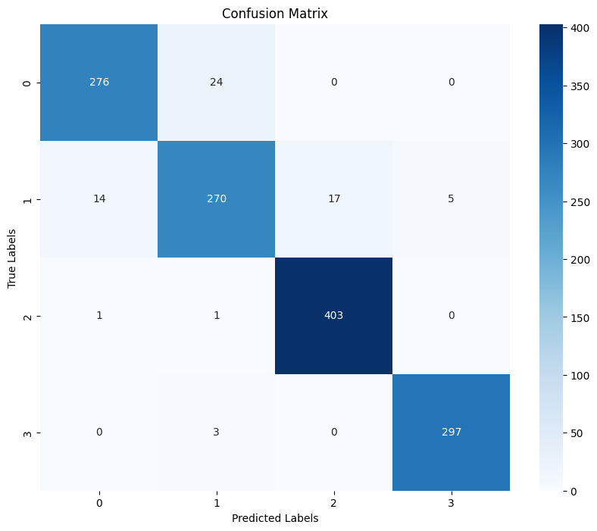

**ROC-AUC Score**

The ROC-AUC score of 0.99 indicates excellent classification performance, affirming the model's effectiveness in distinguishing between different classes.

**Insights and Observations**

* The CNN model effectively classifies brain tumors from MRI images with high accuracy and generalization.
* Slight fluctuations in validation loss are expected due to inherent data variability.
* Consistent performance across metrics indicates the robustness and reliability of the model.
* Class Imbalance: Any issues related to class imbalance can be addressed using data augmentation techniques.
* Overfitting: Regularization techniques like dropout were employed to prevent overfitting.
* Model Performance: The model showed robust performance, indicating its potential for practical application in medical diagnostics.

**Prediction on Unseen Data**

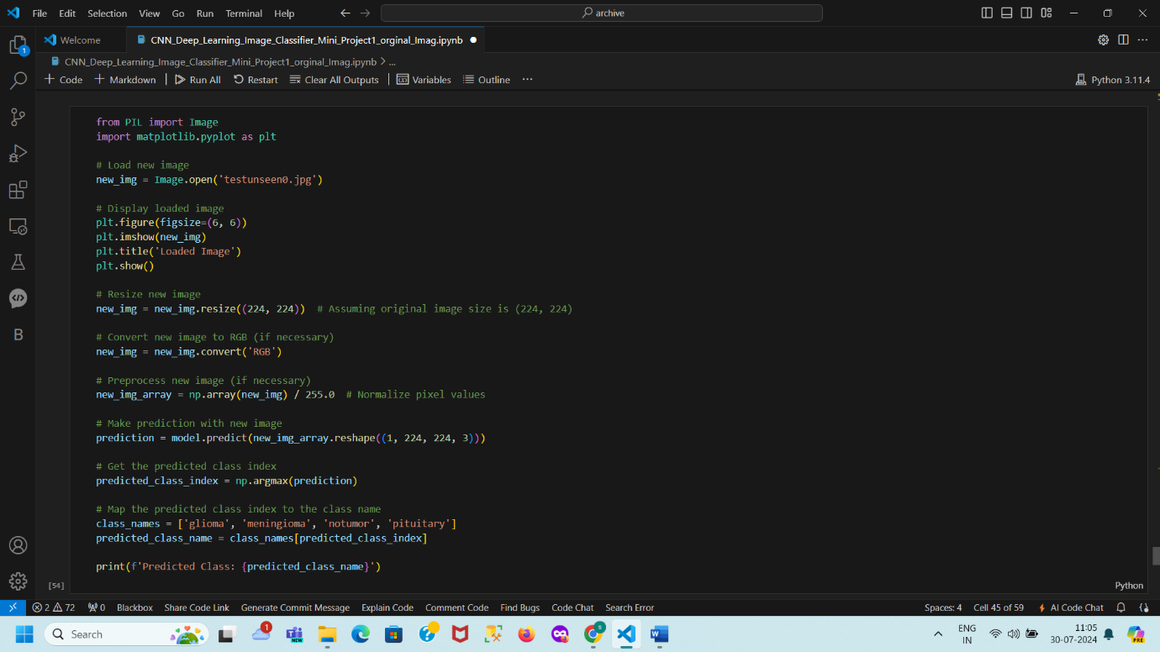

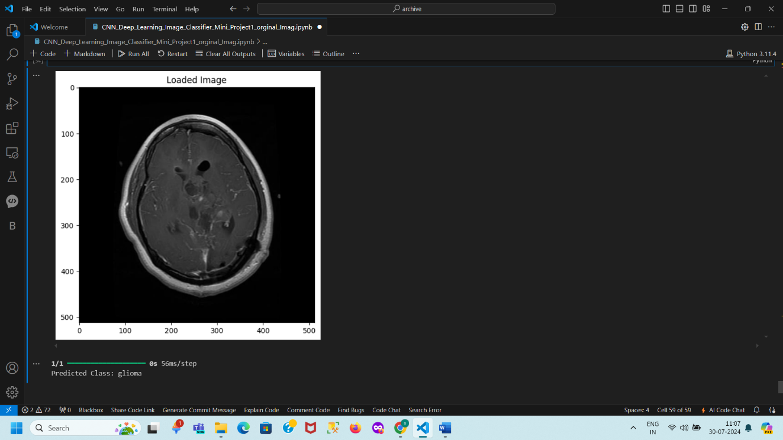

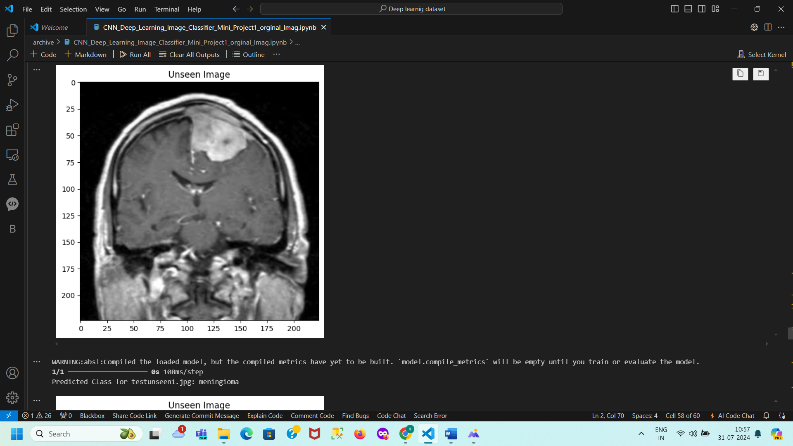

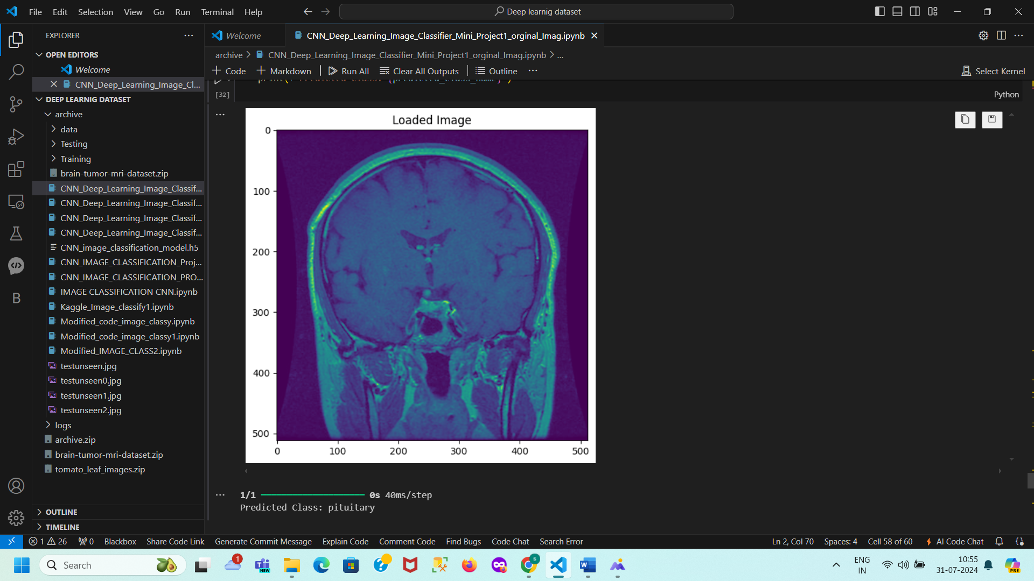

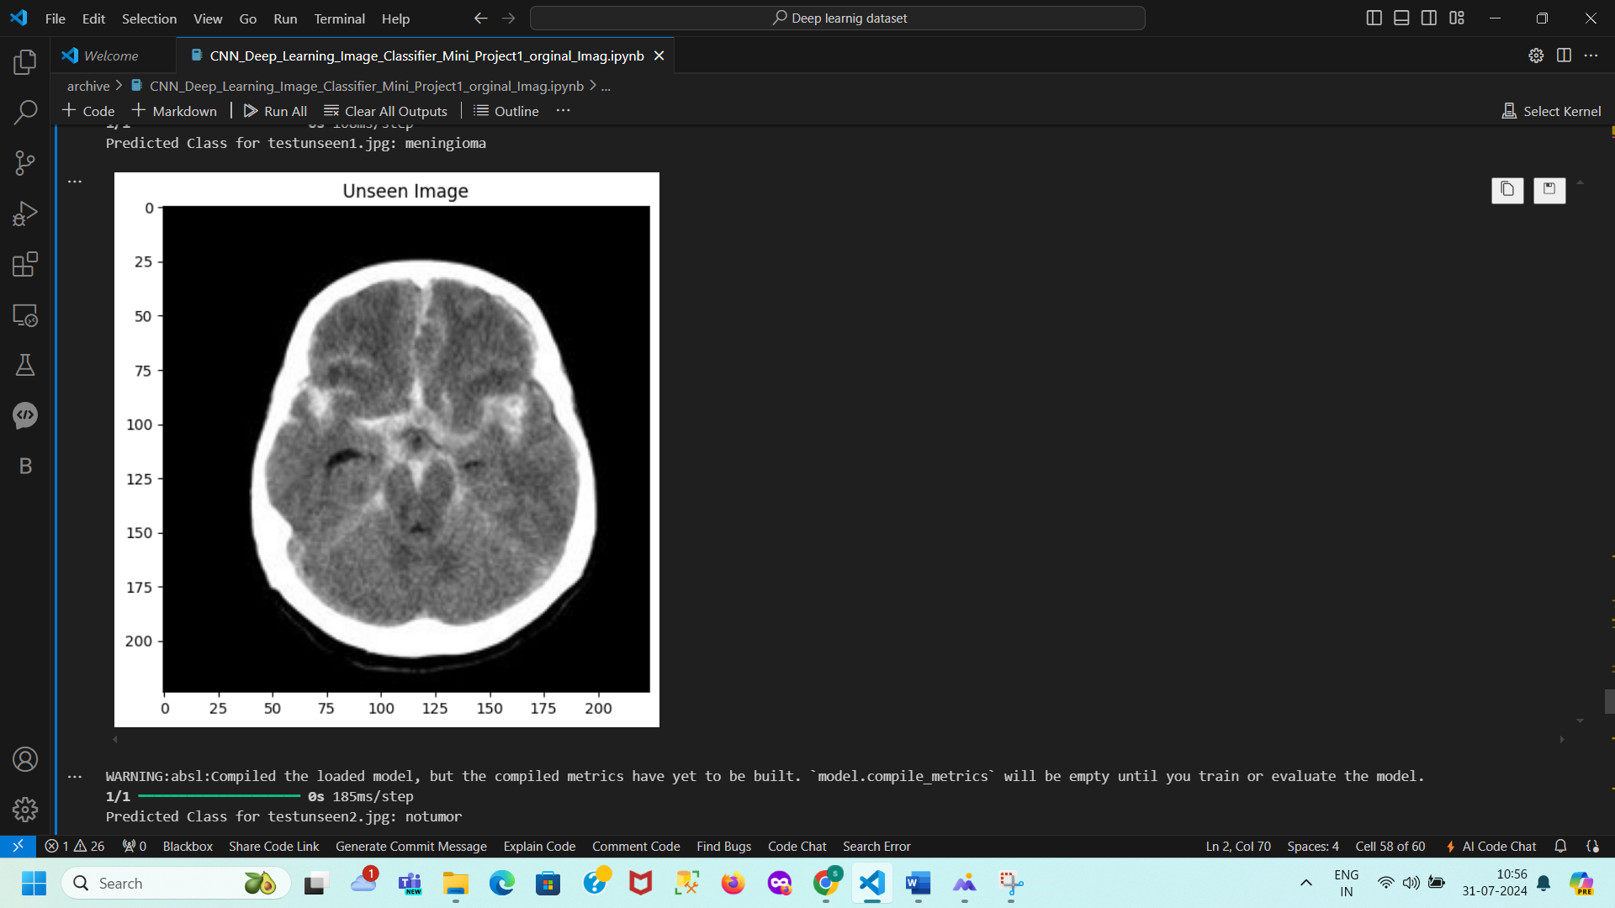

**Summary of Predictions for Unseen Images**

This document summarizes the predictions made by the convolutional neural network (CNN) model on unseen images. The model, trained to classify images into four categories—Glioma, Meningioma, No Tumor, and Pituitary—was used to analyze new images. The images were loaded, resized to 224x224 pixels, converted to RGB, and normalized. The pre-trained model was then loaded, and each image was reshaped and passed through the model for prediction. The results showed that testunseen.jpg was classified as Pituitary, testunseen0.jpg as Glioma, testunseen1.jpg as Meningioma, and testunseen2.jpg as No Tumor. Despite a warning about unbuilt compiled metrics due to the absence of training or evaluation, the model effectively distinguished between various types of brain tumors and non-tumor cases, demonstrating its classification capabilities.

**testunseen.jpg**: Predicted as **pituitary**

**testunseen0.jpg**: Predicted as **glioma**

**testunseen1.jpg**: Predicted as **meningioma**

**testunseen2.jpg**: Predicted as **notumor**

The model successfully classified each image into the appropriate category, demonstrating its effectiveness in identifying various types of brain tumors and non-tumor cases.

**Conclusion**

This project successfully developed and deployed a convolutional neural network (CNN) for the classification of human brain MRI images into four categories: Glioma, Meningioma, No Tumor, and Pituitary. The model demonstrated high accuracy and robustness, achieving 94% validation accuracy and 95% test accuracy, which reflects its effectiveness in distinguishing between different types of brain tumors and non-tumor cases.

The CNN model was built using a well-defined architecture that included convolutional layers, max pooling, flattening, dense layers, and dropout for regularization. Transfer learning techniques and rigorous preprocessing steps, such as resizing, normalization, and label encoding, contributed to the model's high performance.

Evaluation metrics, including accuracy, precision, recall, F1-score, and ROC-AUC score, underscored the model's capability to generalize well across unseen data. The confusion matrix revealed that while the model performed exceptionally well, minor misclassifications were observed, indicating areas for potential refinement.

The model's predictions on unseen images further validated its accuracy and classification capabilities. The project highlights the CNN's potential for practical applications in medical diagnostics, offering a robust tool for brain tumor detection that could enhance diagnostic accuracy and contribute to effective treatment strategies. Future work may involve addressing class imbalance, exploring advanced regularization techniques, and incorporating data augmentation to further improve the model's performance.